Deleting Branches in Git

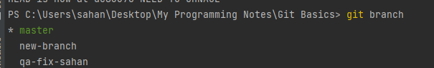

To delete a branch we can use either -d or -D will git branch command

To delete a branch that already merged

Here -d will remove the branch that already merged



To delete branch either merged or nor forcefully

-d Will remove the branch either merged or not merged forcefully



To delete multiple Branches

